TYPE 1
To calculate Rate of Simple Interest when Principal becomes A/B times of itself:
Trick:1
Rate of SI =
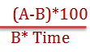

Example 1
At what rate of simple Interest per annum a sum of money becomes 3/2 times of itself in 5 years?

Solution
Rate of Simple Interest =
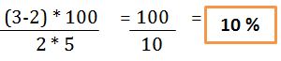

TYPE 2
To calculate Rate of Simple Interest when Interest becomes A/B times of Principal:
Trick:2
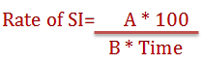

Example 2
At what rate of simple Interest a sum of money becomes 4/25 times of Principal. If number of years is equal to the rate of interest?
Solution:
Let time= X (years)
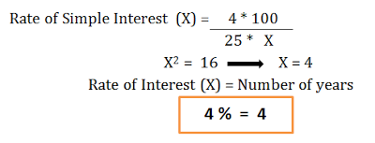

TYPE 3
When a sum of money becomes N1 times in T1 years and N2 times in T2 years
Trick 3
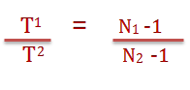

Example 3
A sum of money becomes 7 times of itself in 20 years . In how many years it will become 13 times of itself?

Solution:
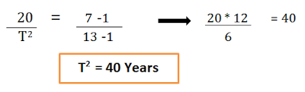

TYPE 4
To calculate Time when Principal becomes N times of itself and rate of Simple Interest is given:
Trick 4
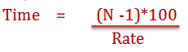

Example 4
In how many years a sum of money becomes 4 times of itself at 10% rate of simple interest?
Solution

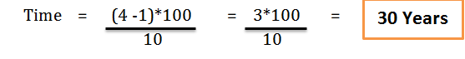

TYPE 5
To calculate Principal when sum of interest or difference of interest for two different years is given
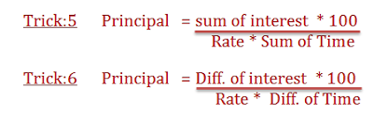

Example 5
At 6 % rate of simple interest per annum the sum of interest for 3 years and 6 years is Rs.270. Calculate the sum?
Solution:
